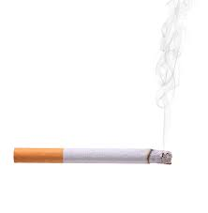

**10 YEARS**

After quitting

**The risk of dying from lung cancer drops 50%**

**1 YEAR**

After quitting

**The risk of heart disease is reduced to 50%**

**2 WEEKS**

After quitting

**Circulation and lung function improve**

**20 MINUTES**

After quitting

**The heart rate and blood pressure drop**

**back to normal**

S

**15 YEARS**

After quitting

**The risk of heart disease is equivalent to a non-smoker**

**5 YEARS**

After quitting

**The risk of throat, oesophagus and bladder cancer drops 50%. Risk of cervical cancer and stroke drop**

**1-9 WEEKS**

After quitting

**Coughs and breathing problems begin to dissapear**

**12 HOURS**

After quitting

**The level of carbon monoxide in the blood drops to normal**